|  |
| --- |
| D:\download\document\clouds.jpg |
| Integration Test (IT)  Version 1.0 |
| |  |  |  | | --- | --- | --- | |  | 3/2/14 | SE323 | |

Contents

URS 1 – The user has to register themselves as customer 2

Sd1 – The user has to register themselves as customer. 2

TC_IT 01: Testing between CustomerServiceImpl and CustomerDAO by checkCustomer() method 2

TC_IT 02: Testing between CustomerServiceImpl and CustomerDAO by register() method 2

URS 2 – User login as a customer 2

SD2 – The user login as a customer 2

TC_IT 03: Testing between CustomerServiceImpl and CustomerDAO by validateUser() method 2

URS-03: The customer update their information 2

Sd3 – The customer update their information 2

TC_IT 04: Testing between CustomerServiceImpl and CustomerDAO by editProfile() method 2

URS-04: The customer search product. 2

SD4 – The customer search product 2

TC_IT 05: Testing between SearchServiceImpl and MediaDAO by searchMediayName() method 2

URS -05: The customer add product to a cart 2

SD5 – The customer add product to a cart 2

TC_IT 06: Testing between OrderServiceImpl and OrderDAO by addItemtoCart() method 2

URS-06: The customer check out for purchase the product. 2

SD6 – The customer checkout for purchase the product 2

TC_IT 07: Testing between OrderServiceImpl and OrderDAO by showOrderDetail() method 2

TC_IT 08: Testing between OrderServiceImpl and OrderDAO by addItemtoCart() method 2

URS-07: The customer view their history. 2

Sd7 – The customer view their history 2

TC_IT 09: Testing between OrderServiceImpl and OrderDAO by addItemtoCart() method 2

TC_IT 10: Testing between OrderServiceImpl and OrderDAO by addItemtoCart() method 2

URS-08: The user log in as administrator 2

SD8 – The user login as administrator 2

TC_IT 11: Testing between LoginServiceImpl and AdminDAO by validateUser() method 2

URS-09: The administrator add a new product. 2

URS-09: The administrator add a new product. 2

TC_IT 12: Testing between MediaServiceImpl and MediaDAO by searchCustomerByUsername() method 2

URS-10: The administrator view customer history 2

Sd10 – The administrator view customer history 2

TC_IT 13: Testing between SearchServiceImpl and CustomerDAO by searchCustomerByUsername() method 2

URS-11: The customer logout from system 2

Sd11 – The customer logout from system 2

TC_IT 14: Testing between LoginServiceImpl and CustomerDAO by setStatus() method 2

URS-12: The administrator logout from system 2

Sd13 – The administrator logout from system. 2

TC_IT 15: Testing between LoginServiceImpl and AdminDAO by setStatus() method 2

# Revision history

## Change Record

|  |  |  |  |
| --- | --- | --- | --- |
| **Version** | **Date** | **Name** | **Revision Description** |
| V1.0 | March 2, 2014 | Panupak Wichaidit | Create Integration test documentation |
|  |  |  |  |
|  |  |  |  |
|  |  |  |  |
|  |  |  |  |

## Reviewer

|  |  |  |
| --- | --- | --- |
| **Name** | **Version Approved** | **Date** |
| Maytat Siriangkul | V1.0 | March 2, 2014 |
|  |  |  |
|  |  |  |
|  |  |  |
|  |  |  |

# References

Sequence diagram

# Introduction

# Integration testing (sometimes called integration and testing, abbreviated I&T) is the phase in software testing in which individual software modules are combined and tested as a group. It occurs after unit testing and before validation testing.

# Responsibility

|  |  |
| --- | --- |
| **Task** | **Team member name** |
| Write IT test plan | Panupak Wichaidit |
| Verify IT test plan | Narangrit Saisuwan |
| Verify IT test plan | Maytat Siriangkul |

# Test Item

Media E-shopping v1.0

# Test tools

Selenium

# Test Environment requirement

##### Display

* 15.4-inch (diagonal) LED-backlit glossy or optional antiglare widescreen display with support for millions of colors

##### Processor

* 2.6GHz quad-core Intel Core i7 processor (Turbo Boost up to 3.6GHz) with 6MB L3 cache

##### Memory

* 2.3GHz  
  4GB of 1600MHz DDR3 memory

# Features to be tested

All of User requirement specification

# URS 1 – The user has to register themselves as customer

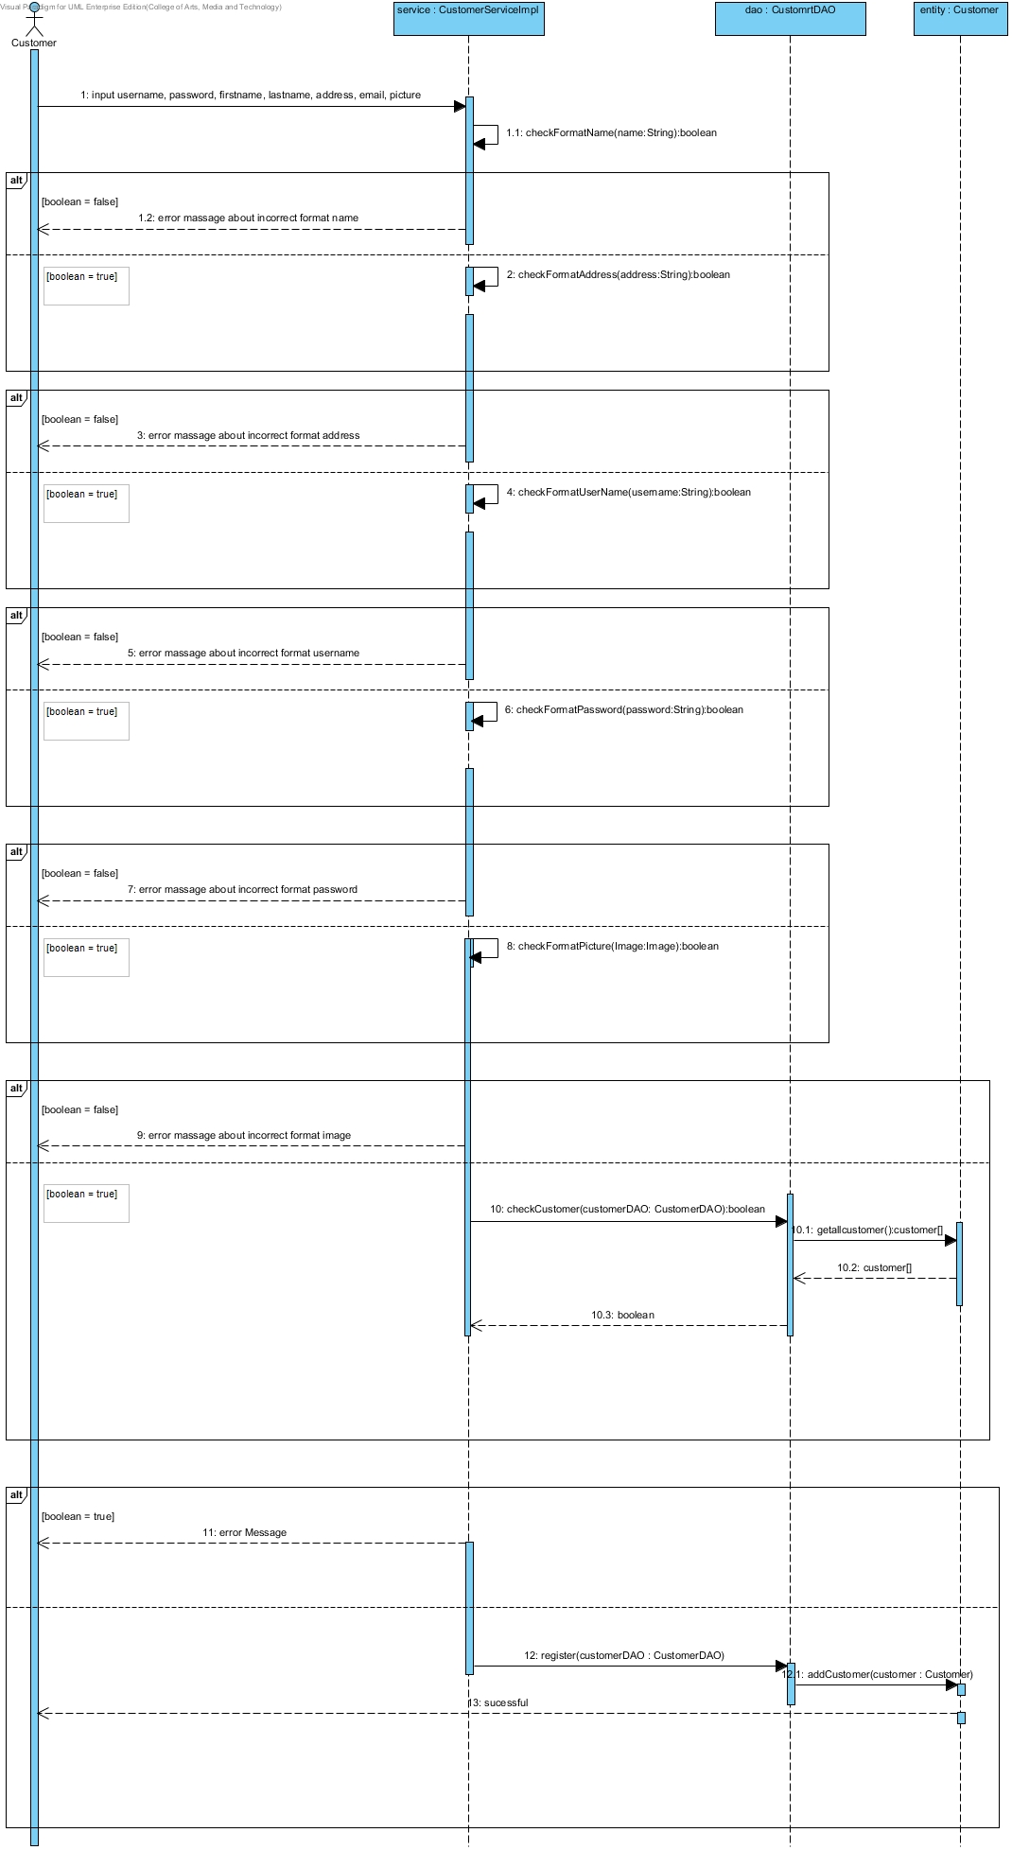

## Sd1 – The user has to register themselves as customer.

### TC_IT 01: Testing between CustomerServiceImpl and CustomerDAO by checkCustomer() method

|  |  |
| --- | --- |
| Test case Identifier: | TC_IT 01 |
| Test Item(s): | CustomerServiceImpl → CustomerDAO |
| Input Specification: | Validate customer’s username has been use or not. |
| Expect Output: | Return false if customer’s username doesn’t match with a data in database. |
| Actual Output: |  |
| Environment: | N/A |
| Test status: |  |

#### Data Input

|  |  |
| --- | --- |
| Username: | cus01 |

### TC_IT 02: Testing between CustomerServiceImpl and CustomerDAO by register() method

|  |  |
| --- | --- |
| Test case Identifier | TC_IT 02 |
| Test Item(s) | CustomerServiceImpl → CustomerDAO |
| Input Specification | Add new customer into a database. |
| Expect Output | Show Successful registration page |
| Actual Output |  |
| Environment | TC_IT 01 succeeded |
| Test status: |  |

#### Data Input

**Customer object**

|  |  |
| --- | --- |
| Frist name: | Panupak |
| Last name: | Wichaidit |
| Address: | home |
| Tel: | 0884035121 |
| Email: | newnok6@gmail.com |
| Image: | Cus1.jpg |
| Username: | Cus01 |
| Password: | 1234 |

# URS 2 – User login as a customer

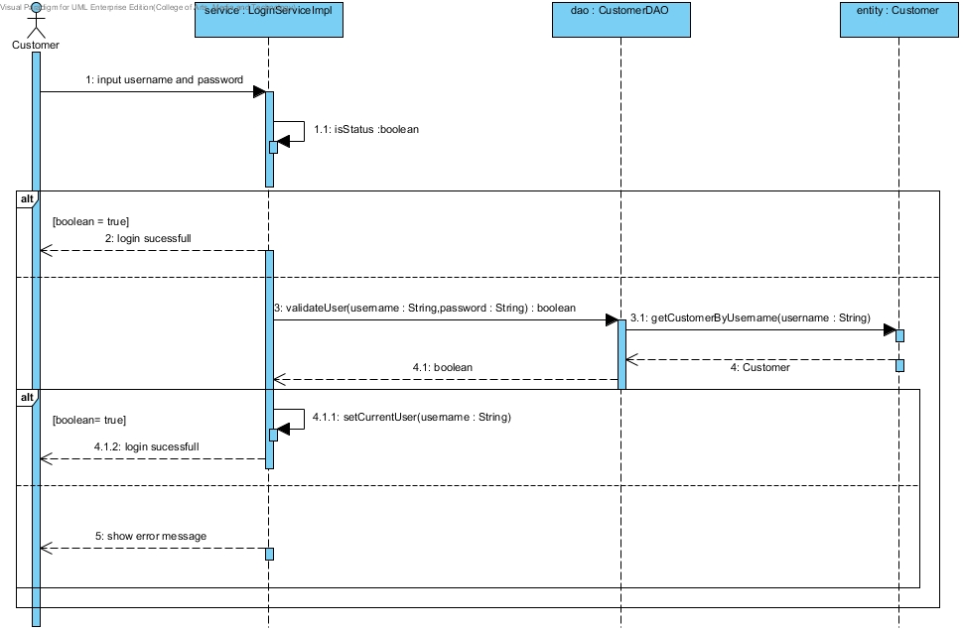

## SD2 – The user login as a customer

### TC_IT 03: Testing between CustomerServiceImpl and CustomerDAO by validateUser() method

|  |  |
| --- | --- |
| Test case Identifier | TC_IT 03 |
| Test Item(s) | CustomerServiceImpl → CustomerDAO |
| Input Specification | Validate customer account from username and password that user input |
| Expect Output | Return true if username and password is match with database. |
| Actual Output |  |
| Environment | N/A |
| Test status: |  |

#### Data Input

|  |  |
| --- | --- |
| Username: | cus01 |
| Password : | 1234 |

# URS-03: The customer update their information

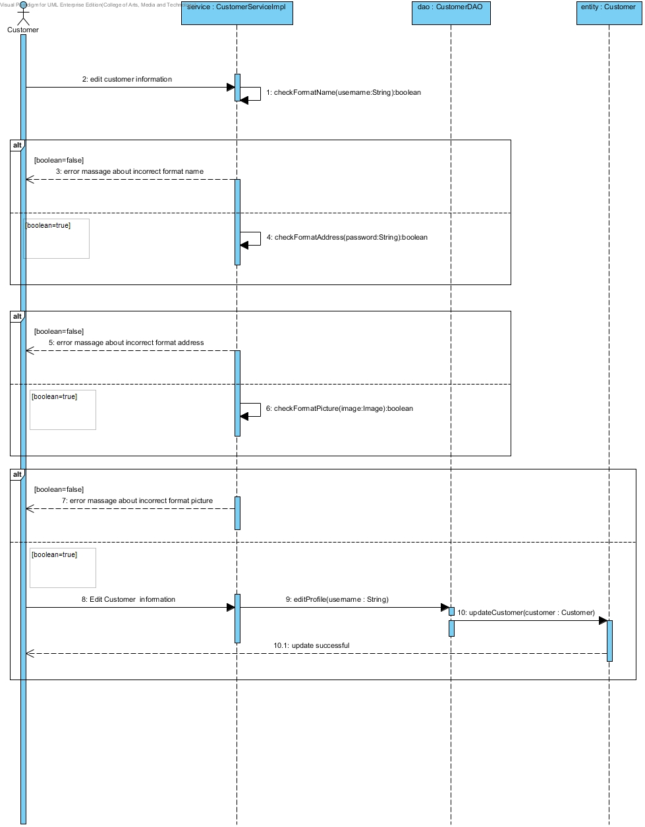

## Sd3 – The customer update their information

### TC_IT 04: Testing between CustomerServiceImpl and CustomerDAO by editProfile() method

|  |  |
| --- | --- |
| Test case Identifier | TC_IT 04 |
| Test Item(s) | CustomerServiceImpl → CustomerDAO |
| Input Specification | Update the customer’s information. |
| Expect Output | Return true, if customer updating is successful. |
| Actual Output |  |
| Environment | TC_IT 03 succeeded |
| Test status: |  |

#### Data Input

|  |  |
| --- | --- |
| Frist name : | Panupak2 |

# URS-04: The customer search product.

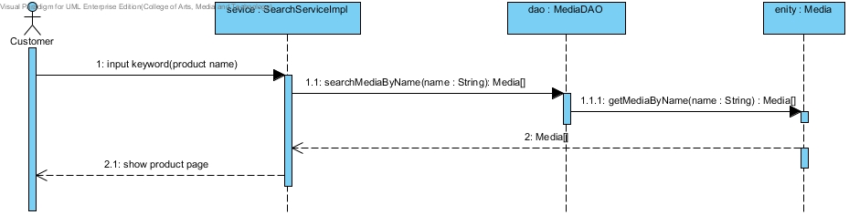

## SD4 – The customer search product

### TC_IT 05: Testing between SearchServiceImpl and MediaDAO by searchMediayName() method

|  |  |
| --- | --- |
| Test case Identifier | TC_IT 05 |
| Test Item(s) | SearchServiceImpl → MediaDAO |
| Input Specification | Search a product follow a product’s name that a user input. |
| Expect Output | Return a list of product that similar with keyword from user |
| Actual Output |  |
| Environment | N/A |
| Test status: |  |

#### Data Input

|  |  |
| --- | --- |
| Product name : | Frozen |

# URS -05: The customer add product to a cart

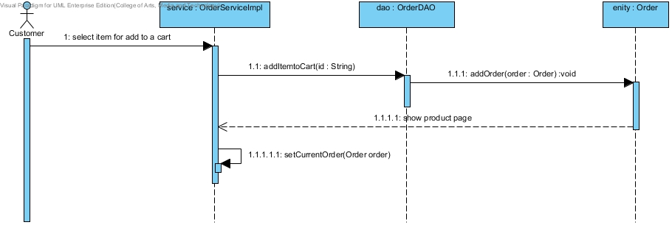

## SD5 – The customer add product to a cart

### TC_IT 06: Testing between OrderServiceImpl and OrderDAO by addItemtoCart() method

|  |  |
| --- | --- |
| Test case Identifier | TC_IT 06 |
| Test Item(s) | OrderServiceImpl → OrderDAO |
| Input Specification | Add product into a cart. |
| Expect Output | Show product page and number counter is increase |
| Actual Output |  |
| Environment | TC_IT 03 succeeded |
| Test status: |  |

#### Data Input

|  |  |
| --- | --- |
| Product name : | Frozen |
| Quantity : | 5 |

# URS-06: The customer check out for purchase the product.

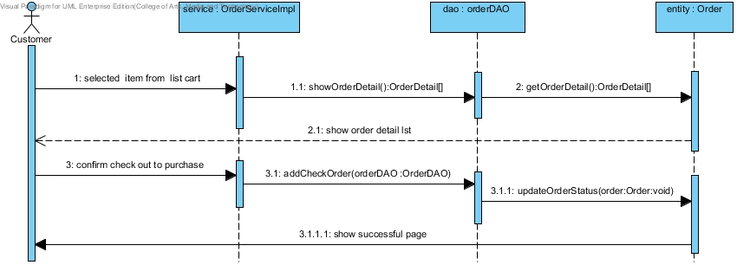

## SD6 – The customer checkout for purchase the product

### TC_IT 07: Testing between OrderServiceImpl and OrderDAO by showOrderDetail() method

|  |  |
| --- | --- |
| Test case Identifier | TC_IT 07 |
| Test Item(s) | OrderServiceImpl → OrderDAO |
| Input Specification | Request to show order detail in a cart such as a list of product and total price. |
| Expect Output | Show order detail in a cart as a list of items. |
| Actual Output |  |
| Environment | TC_IT 03 succeeded |
| Test status: |  |

#### Data Input

N/A

### TC_IT 08: Testing between OrderServiceImpl and OrderDAO by addItemtoCart() method

|  |  |
| --- | --- |
| Test case Identifier | TC_IT 06 |
| Test Item(s) | OrderServiceImpl → OrderDAO |
| Input Specification | Check out the order that in a cart. |
| Expect Output | The order is update and show successful page. |
| Actual Output |  |
| Environment | TC_IT 03,TC_IT 07 succeeded |
| Test status: |  |

#### Data Input

N/A

# URS-07: The customer view their history.

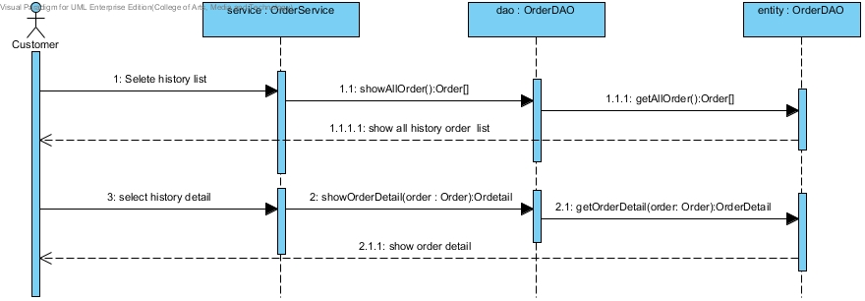

## Sd7 – The customer view their history

### TC_IT 09: Testing between OrderServiceImpl and OrderDAO by addItemtoCart() method

|  |  |
| --- | --- |
| Test case Identifier | TC_IT 09 |
| Test Item(s) | OrderServiceImpl → OrderDAO |
| Input Specification | Request to show all of the order list. |
| Expect Output | Show a list of the order |
| Actual Output |  |
| Environment | TC_IT 03 succeeded |
| Test status: |  |

#### Data Input

N/A

### TC_IT 10: Testing between OrderServiceImpl and OrderDAO by addItemtoCart() method

|  |  |
| --- | --- |
| Test case Identifier | TC_IT 10 |
| Test Item(s) | OrderServiceImpl → OrderDAO |
| Input Specification | Request to show each of the order detail. |
| Expect Output | Show each of the order detail. |
| Actual Output |  |
| Environment | TC_IT 03 , TC_IT 09 succeeded |
| Test status: |  |

#### Data Input

N/A

# URS-08: The user log in as administrator

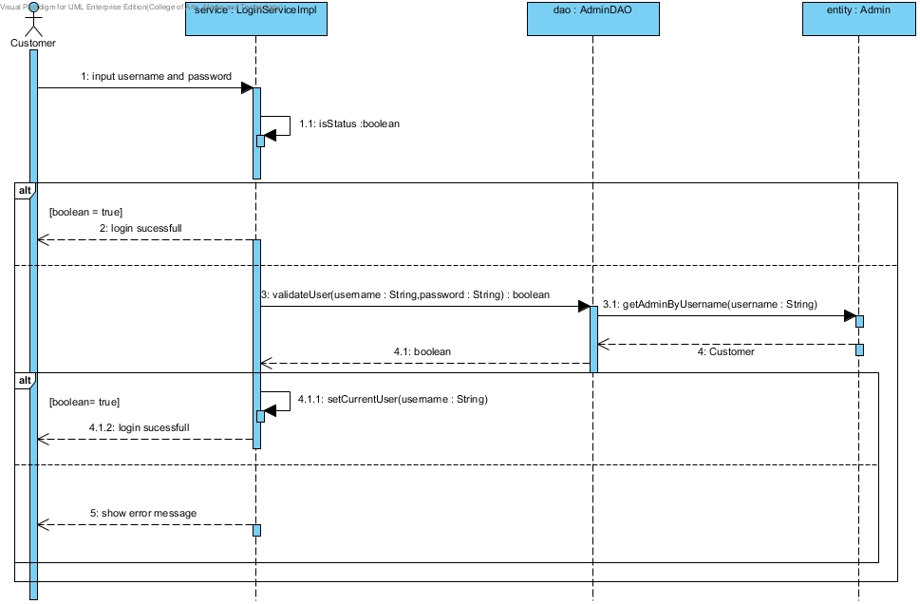

## SD8 – The user login as administrator

### TC_IT 11: Testing between LoginServiceImpl and AdminDAO by validateUser() method

|  |  |
| --- | --- |
| Test case Identifier | TC_IT 11 |
| Test Item(s) | CustomerServiceImpl → CustomerDAO |
| Input Specification | Validate customer account from username and password that user input |
| Expect Output | Return true if username and password is match with database. |
| Actual Output |  |
| Environment | N/A |
| Test status: |  |

#### Data Input

|  |  |
| --- | --- |
| Username: | admin01 |
| Password : | 1234 |

# URS-09: The administrator add a new product.

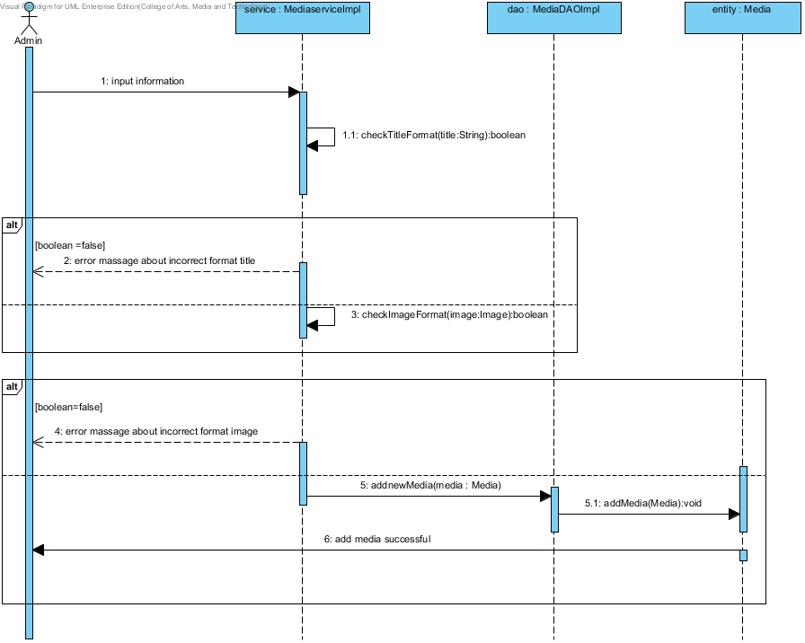

## URS-09: The administrator add a new product.

### TC_IT 12: Testing between MediaServiceImpl and MediaDAO by searchCustomerByUsername() method

|  |  |
| --- | --- |
| Test case Identifier | TC_IT 12 |
| Test Item(s) | MediaServiceImpl → MediaDAO |
| Input Specification | Add a new media into a database. |
| Expect Output | Show successful to adding. |
| Actual Output |  |
| Environment | N/A |
| Test status: |  |

#### Data Input

|  |  |
| --- | --- |
| **Media Name:** | Hobbit an Unexpected Journey |
| **Type :** | Blu-ray 3D |
| **Genre:** | Fantasy |
| **quantity :** | 20 |
| **Unit price:** | 1500.00 |
| **Picture:** | media_03.jpg |
| **Status:** | In-stock |
| **Release Date:** | 08/04/2013 |

# URS-10: The administrator view customer history

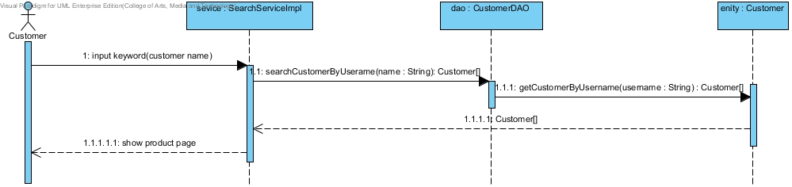

## Sd10 – The administrator view customer history

### TC_IT 13: Testing between SearchServiceImpl and CustomerDAO by searchCustomerByUsername() method

|  |  |
| --- | --- |
| Test case Identifier | TC_IT 13 |
| Test Item(s) | SearchServiceImpl → CustomerDAO |
| Input Specification | Search a customer by keyword that user input. |
| Expect Output | Return a list of customers that similar with keyword. |
| Actual Output |  |
| Environment | N/A |
| Test status: |  |

#### Data Input

|  |  |
| --- | --- |
| Username: | cus01 |
| Password : | 1234 |

# URS-11: The customer logout from system

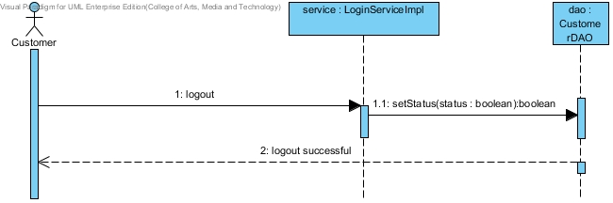

## Sd11 – The customer logout from system

### TC_IT 14: Testing between LoginServiceImpl and CustomerDAO by setStatus() method

|  |  |
| --- | --- |
| Test case Identifier | TC_IT 14 |
| Test Item(s) | LoginServiceImpl → CustomerDAO |
| Input Specification | Request to logout from system. |
| Expect Output | Show logout successful |
| Actual Output |  |
| Environment | N/A |
| Test status: |  |

# URS-12: The administrator logout from system

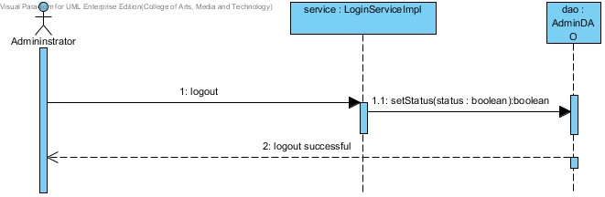

## Sd13 – The administrator logout from system.

### TC_IT 15: Testing between LoginServiceImpl and AdminDAO by setStatus() method

|  |  |
| --- | --- |
| Test case Identifier | TC_IT 15 |
| Test Item(s) | LoginServiceImpl → AdminDAO |
| Input Specification | Request to logout from system. |
| Expect Output | Show logout successful |
| Actual Output |  |
| Environment | N/A |
| Test status: |  |

# Pass and Fail criteria

Pass- the Integration test is pass when all of the test case is pass.

Fail – When miss only one pass test case

# Member

Narungrit Saisuwan 542115017

Panupak Wichaidit 542115047

Maytat Siriangkul 542115050